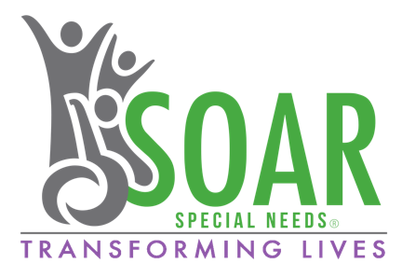
Declaration of Consent
Please indicate your consent to each item by signing below each statement.

Emergency Medical Treatment Consent
- I, ___________________, parent/guardian of __________________ give permission to the medical personnel selected by SOAR Special Needs to order hospitalization, treatment, anesthesia, and surgery if necessary, in case of an emergency when parents cannot be reached.

_________________________ _________________________
Signature Date

Photograph Release Consent
- I, _____________________, parent/guardian of ________________ give SOAR Special Needs permission to use my child’s name and/or picture in presentations, media releases, newsletters and marketing materials solely for the purpose of promoting the SOAR Special Needs.

________________________ _________________________
Signature Date

Waiver of Liability Consent
- I, ____________________, parent/guardian of ________________ agree to release SOAR Special Needs and event host facility and all staff and volunteers from all liability for any additional illness or injury to my child, and for any accidental damage or destruction of my child’s property during the provision of respite care services.

________________________ __________________________
Signature Date

Thank you for your cooperation. If you have any questions, please contact SOAR Special Needs at 816-782-SOAR (7627) or info@soarspecialneeds.org.

